Chamber Website Project Plan

**1. The Chamber Logo**

**2. THE COLOR PALLETTE**

**The colors URL**

<https://coolors.co/ffa9e7-ff84e8-7f2ccb-414361-2a2d43>

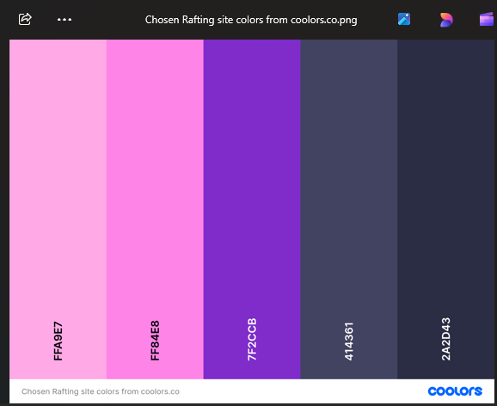

Primary color: FF84E8

Secondary color: 7F2CCB

Accent1-color: FFA9E7

Accent2-color: 414361

**MY FONTS**

Heading – font: roboto

Text – font: Montserrat

<link rel="preconnect" href="https://fonts.googleapis.com">

<link rel="preconnect" href="https://fonts.gstatic.com" crossorigin>

<link href="https://fonts.googleapis.com/css2?family=Montserrat:ital,wght@0,100..900;1,100..900&family=Roboto:ital,wght@0,100;0,300;0,400;0,500;0,700;0,900;1,100;1,300;1,400;1,500;1,700;1,900&display=swap" rel="stylesheet">